UIAO‑Document‑Report — User’s Guide
Chapter 4 — Analysis Workflow
This chapter explains how UIAO‑Document‑Report performs its analysis, how each stage interacts with the repository, and how the tool produces deterministic, repeatable results. The workflow is intentionally modular, allowing each component to operate independently while contributing to a unified reporting pipeline.

Image 4‑1 — High‑Level Analysis Workflow
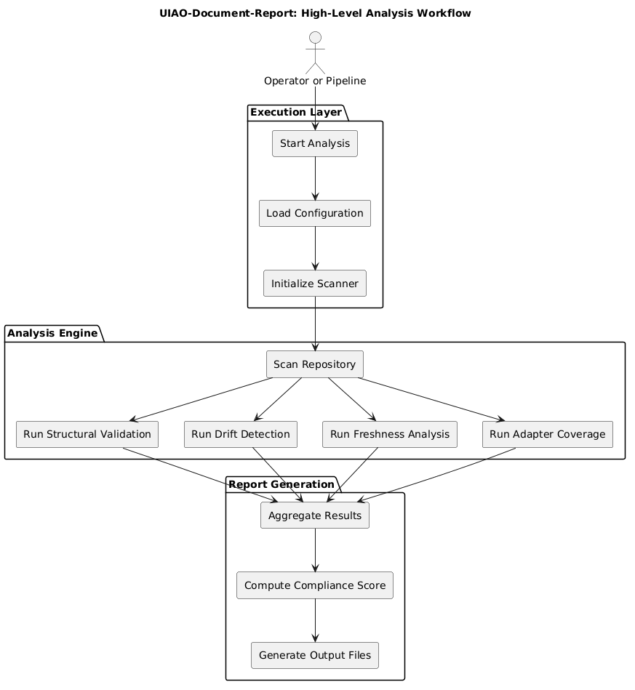
Image 4-1: High-Level Analysis Workflow
@startuml
skinparam backgroundColor white
skinparam componentStyle rectangle
title UIAO-Document-Report: High-Level Analysis Workflow
actor "Operator or Pipeline" as OP
package "Execution Layer" {
[Start Analysis] as SA
[Load Configuration] as LC
[Initialize Scanner] as IS
}
package "Analysis Engine" {
[Scan Repository] as SR
[Run Structural Validation] as SV
[Run Drift Detection] as DD
[Run Freshness Analysis] as FA
[Run Adapter Coverage] as AC
}
package "Report Generation" {
[Aggregate Results] as AR
[Compute Compliance Score] as CS
[Generate Output Files] as GO
}
OP --> SA
SA --> LC
LC --> IS
IS --> SR
SR --> SV
SR --> DD
SR --> FA
SR --> AC
SV --> AR
DD --> AR
FA --> AR
AC --> AR
AR --> CS
CS --> GO
caption Image 4-1: High-Level Analysis Workflow
@enduml
---
> **Source Code Reference:** Python objects for this chapter are defined in `src/uiao_document_report/workflow.py`.

